# Question#1:

Complete ERD

1. With Complete Normalized Relations

# Answer#1:

ERD Diagram of Sabzi Mandi Management System

## Description Of ERD:

**Entities:**

* Admin
* Vendors
* Customers
* Items
* Fruit List
* Vegetable List

**Relations:**

* Admin approves the vegetable List and the fruit List.
* Fruit List and the Vegetable List are given to the vendors.
* Fruit List and the Vegetable List is viewed by the customer.
* Vegetable List have vegetable List Item.
* Fruit List have Fruit List Item.
* Items present in the vegetable list and the fruit list.

**Scenario:**

In Sabazi Mandi Management System, admin is responsible for entering the data to the database and responsible for approving the lists which contain the data present in database. The list view will be generated, and it would only be available for view (i.e read only access) to the customers and vendors who are registered in the database. The customers and vendors are not able to update or change the list.

## ERD Diagram:

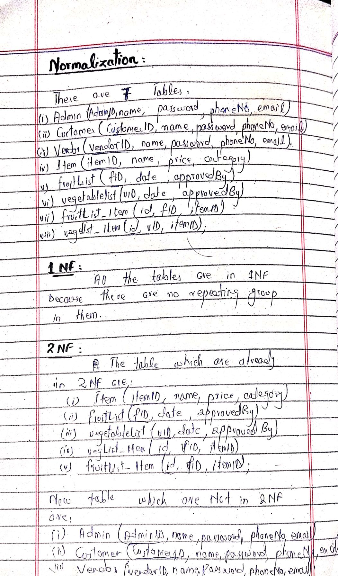NORMALIZATION

